Name of Student: Akshit Kumar | PRN:25070122270
Semester: III | Year : AY 2026-27
Subject: Programming with Java
ASSIGNMENT No : 10
TITLE : Abstract Classes and Methods
Problem Statement
Write a Java program to demonstrate the use of abstract classes and abstract methods
Learning Objectives
To implement abstraction using abstract classes and abstract methods.

Programme
1.Create an abstract Payment class and implement Credit Card and UPI payment classes.

abstract class Payment {

abstract void makePayment(double amount);
void paymentMessage() {
System.out.println("Payment processing started...");
}
}

// credit card payment
class CreditCardPayment extends Payment {

@Override
void makePayment(double amount) {
System.out.println("Payment Method: Credit Card");
System.out.println("Amount Paid: " + amount);
System.out.println("Credit Card payment successful.");
}
}
// upi payment
class UPIPayment extends Payment {

@Override
void makePayment(double amount) {
System.out.println("Payment Method: UPI");
System.out.println("Amount Paid: " + amount);
System.out.println("UPI payment successful.");
}
}

public class PaymentDemo {
public static void main(String[] args) {

Payment payment1 = new CreditCardPayment();
Payment payment2 = new UPIPayment();
System.out.println("----- Credit Card Payment -----");
payment1.paymentMessage();
payment1.makePayment(1500);

System.out.println();

System.out.println("----- UPI Payment -----");
payment2.paymentMessage();
payment2.makePayment(800);
}
}

2) Create an abstract FoodOrder class with an abstract method calculateBill(). Implement two subclasses, DineInOrder and TakeAwayOrder, to calculate and display the total bill based on the order type.

abstract class FoodOrder {
double foodAmount;

FoodOrder(double foodAmount) {
this.foodAmount = foodAmount;
}

abstract void calculateBill();

void displayFoodAmount() {
System.out.println("Food Amount: " + foodAmount);
}
}

class DineInOrder extends FoodOrder {

DineInOrder(double foodAmount) {
super(foodAmount);
}

@Override
void calculateBill() {
double serviceCharge = foodAmount * 0.10;
double totalBill = foodAmount + serviceCharge;

System.out.println("Order Type: Dine-In");
displayFoodAmount();
System.out.println("Service Charge (10%): " + serviceCharge);
System.out.println("Total Bill: " + totalBill);
}
}

class TakeAwayOrder extends FoodOrder {
TakeAwayOrder(double foodAmount) {
super(foodAmount);
}

@Override
void calculateBill() {
double packagingCharge = 50;
double totalBill = foodAmount + packagingCharge;

System.out.println("Order Type: Take-Away");
displayFoodAmount();
System.out.println("Packaging Charge: " + packagingCharge);
System.out.println("Total Bill: " + totalBill);
}
}
public class FoodOrderDemo {
public static void main(String[] args) {
FoodOrder order1 = new DineInOrder(500);
FoodOrder order2 = new TakeAwayOrder(500);
System.out.println("--- Dine-In Order ---");
order1.calculateBill();

System.out.println();

System.out.println("--- Take-Away Order ---");
order2.calculateBill();
}
}

Output
1)
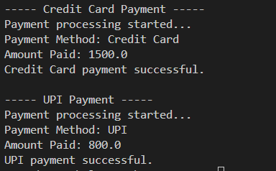
2)
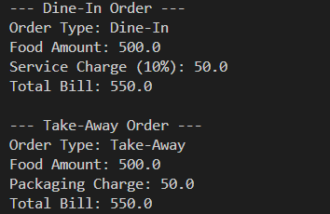
Conclusion
Thus, the programs successfully demonstrate the use of abstract classes and abstract methods in Java.

